Der CAMPINGPLATZ *** LA DIGUE liegt in der kleinen Gemeinde Chauzon im Herzen der südlichen Ardèche, wenige Kilometer von RUOMS entfernt. Die Gegend um Ruoms wird wegen des milden mediterranen Klimas, der hervorragend schönen Schluchtenlandschaft und der klaren Flüsse sehr geschätzt. Es ist ein Paradies zum KANU- und KAJAKFAHREN, zum Schwimmen und Wandern ! 2 Kilometer vom Campingplatz laden erschlossene Felswände zum KLETTERN ein.

Der Campingplatz liegt sehr ruhig direkt am Ufer der ARDECHE,
images/plage3-g.jpgFehler! Textmarke nicht definiert.images/plage3-g.jpginmitten unberührter Natur und schattenspendender Bäume - ideal für erholsame und sportliche Ferien mit der Familie oder mit Freunden.
Öffnungszeiten: vom 20. März bis 6. November.

CAMPING LA DIGUE
CHAUZON
07120 RUOMS
Tél. : +33 (0) 4 75 39 63 57 +33 (0) 4 75 39 63 80
http://www.camping-la-digue.fr

Preise in euros,  pro Tag | Hauptsaison  (Juli-August) | Vor-Nachsaison  (Frühjahr und Sept- November)
Gesamtpreis für 2 Personen | 16.5 | 13.5
Zusätzliche Personen | 4.5 | 4
Kinder unter 7 Jahren | 2.5 | 1.8
Elektroanschluss | 4 | 3.5
Hund | 1.5 | entgeltlich
GRUPPENTARIFE  Pro Person / pro Nacht | 5 | 4

Zufahrt zum CAMPINGPLATZ *** LA DIGUE
Fabienne et Jean-Louis ELNE
CAMPING LA DIGUE
CHAUZON
07120 RUOMS
Tél. : +33 (0) 4 75 39 63 57
Fax : +33 (0) 4 75 39 75 17
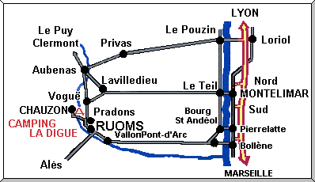

Aktivitäten auf dem CAMPINGPLATZ *** LA DIGUE
KANU- UND KAJAKVERLEIH:
Der CAMPINGPLATZ *** LA DIGUE (Ardèche) zentral gelegen in der Nähe von 4 Flüssen, der Categorie 2 bis 4. Wir verleihen alles was man zum Kajakfahren braucht und begleiten und unterrichten falls erwünscht.
Weitere Aktivitäten:
Bademöglichkeiten im Fluss
Beheiztes Schwimmbad (mit Kinderbecken)
Mountainbike - Verleih
Tennis
Tischtennis
Volleyball
Angeln
Boules
Wanderungen
Kinderspielplatz

Cirque de Gens - Chauzon
10 Kilometer von der berühmten Ardèche-Schlucht entfernt befinden sich mehrere Klettergebiete. Der CIRQUE DE GENS ist ein Klettergebiet direkt neben dem Dorf CHAUZON und in unmittelbarer Nähe zum CAMPINGPLATZ *** LA DIGUE. RUOMS, ein Touristen-, sowie Einkaufszentrum, ist in wenigen Minuten zu erreichen.
Das Klettergebiet eignet sich für Kletterer jeder Qualifikation. In der halbkreisförmigen Schlucht scheint den ganzen Tag die Sonne. Besonders im Frühling und im Herbst findet man in dieser windgeschützten Umgebung optimale Kletterbedingungen
.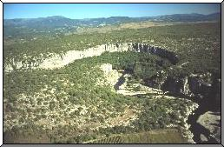 Cirque de Gens
Die vielen Routen sind sehr gut präpariert und liegen in einer natürlichen Umgebung:

Klettergebiet des  CIRQUE DE GENS |  |  | SCHWIERIGKEITSGRADE
Anzahl der Routen | Schwierigkeitsgrade  FRANKREICH | Schwierigkeitsgrade  UIAA | Schwierigkeitsgrade  GB | Schwierigkeitsgrade  D
14 | 4 | IV | 4a | IV
14 | 5 | V- / VI- | 4b / 5a | V / VIIb
46 | 6a | VI /VI+ | 5b | VIIc
63 | 6b | VII- / VII | 5c | VIIIa / VIIIb
45 | 6c | VII+ / VIII- | 5c / 6a | VIIIc / IXa
64 | 7a | VIII- / VIII | 6a / 6b | IXb
39 | 7b | VIII+ / IX- | 6b | IXc / Xb
22 | 7c | IX- / IX | 6c | Xb / Xc
5 | 8a | IX+ / X- | 7a | Xc

Weitere Klettergebiete
Im Umkreis von 15 Kilometer des CAMPINGPLATZ *** LA DIGUE gibt es die unterschiedlichsten Klettermöglichkeiten:
ALAZUC:  CASTELJAU:  (MAZET - CHAULET)  SALAVAS: | 99 Routen  354 Routen  + Bouldergebiet  127 Routen

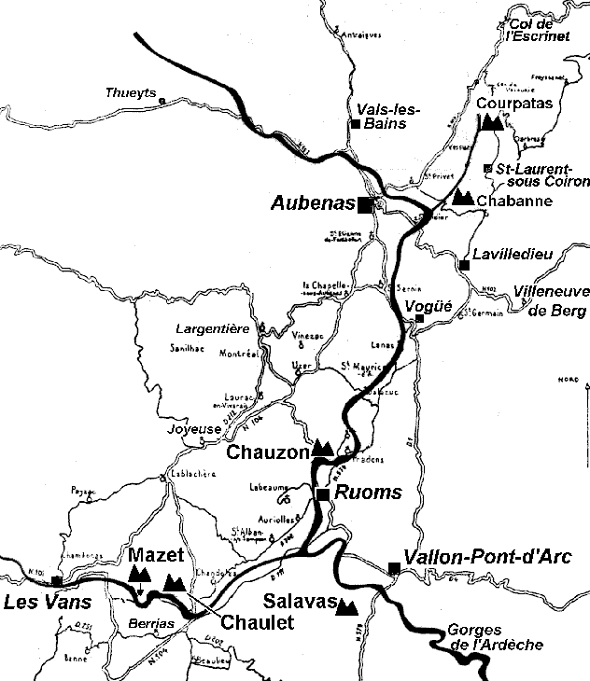

The Ardèche departement is one of the first French departements whose Departement Council (Conseil Général) decided to invest a lot of money in climbing site equipment. One reason for that is that the Ardèche departement has an important income due to tourism, and rock climbing is an interesting ``touristic product'' for local economies.
The higher Cévennes mountains are rather left with their rugged and often rainy climate, so that most climbing areas and tourists concentrate in the Ardèche valley between Pont-Saint-Esprit and Aubenas, and in the Chassezac valley between Vallon-Pont-d'Arc and Les Vans.
This you will find there many weel equipped crags, with many (some climbers state ``too many'') routes of all orientations: north-west faces for summer, south sides for chilly seasons. Unfortunately, there is also a drawback, namely that uncountable campsites and holiday villages bring climbing crowds which accumulate in Chaulet, Mazet-Plage, Salavas-Font-Garnide and also Chauzon. If your level is good and you like quiet places, you are suggested to visit Chabanne and le Courpatas, two limestone crags lost on the edge of the basaltic Coirons plateau.

Topos-guides
- Guide des sites d'escalade de l'Ardèche, Comité Départemental FFME Ardèche, 1999, 150 F ;
en vente / on sale:
- Intersport, 18, bd Pasteur, 07200 Aubenas
- Maison de l'Escalade, 07400 Casteljau (au-dessus de / above Mazet-Plage
- Vallon-Pont-d'Arc (diverses boutiques / various shops)
- Par correspondance / by mail : CD-FFME Ardèche, 2, rue Pierre Filliat, F-07000 PRIVAS,120 RUOMS, 04.75.64.85.54, fax 04.75.64.75.40, http://www.ffme.fr/cd/07 (inclure un chèque de 150 FF).

Gîtes/Lodge, Camping
- Nombreux campings autour de Vallon-Pont-d'Arc, par exemple :
- http://www.camping-la-digue.fr/index.htm

*** Courpatas
Located 4.5 km SSW of the Col de l'Escrinet (N104, Privas-Aubenas), Courpatas is an upper jurassic limestone crag, with narrow flat holds and many cracks. Facing west it overlooks above the small Louyre valley, the same which passes below Chabanne further south. 130 routes, 20-25 m, 5a-8a.
Very quiet place, away from crowds; not climbable in case Mistral wind. Equipment has been reviewed in 1992-1993, and is now good.

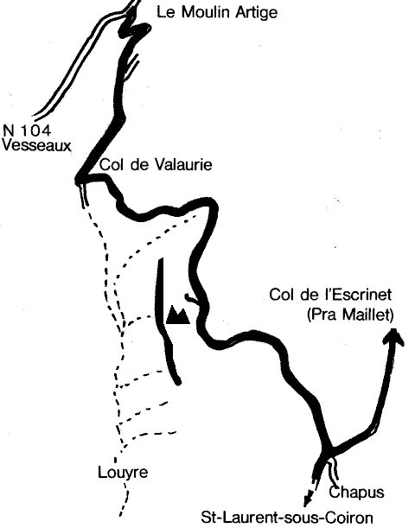

Cartes / Maps
- Michelin : No. 76, pli/folder 19
- IGN 1:25000 : 2937-O

Topos-guides
- Guide des sites d'escalade de l'Ardèche, Comité Départemental FFME Ardèche, 1999.

Accès / Access
Leave road N104 (Privas -- Aubenas) 5 km south of Col de l'Escrinet, at a place named Moulin-Artige (inn); turn SE (left when coming from Privas) on a dirt road, pass two hairpins and turn right (S) at a fork to reach Col de Valaurie (1.5 km from N104) ; take left (NNE) a level curve road leading to the summit of the crag (visible from Valaurie pass) in 1 km; in front of a farm, turn right (SW) on a vague trail leading to a parking on the edge of the plateau.

*** Chabanne
Located 6 km east of Aubenas, Chabanne is a long crag facing west on the left bank of Louyre stream, 2.5 km upstream of its confluent with Ardèche river. Rock is kimmeridgian limestone with narrow flat holds and poor friction. 140 routes, 20-25 m, 4c-7c.
Chabanne is the place which you must visit if you feel too strong for the remainder of the region. A few poorly interesting 4c routes, several athletic 5c routes, more than a hundred severely rated from 6a+ to 7c.
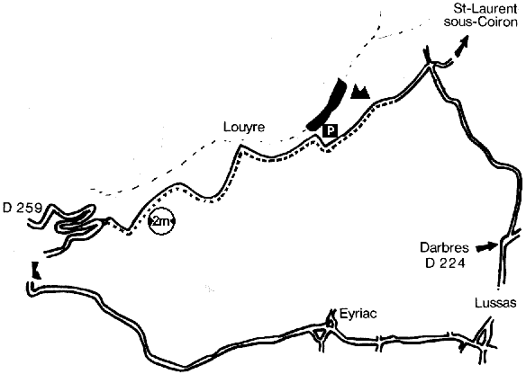

Cartes / Maps
- Michelin : No. 76, pli/folder 19
- IGN 1:25000 : 2938-O

Topos-guides
- Guide des sites d'escalade de l'Ardèche, Comité Départemental FFME Ardèche, 1999.

Accès / Access
Leave N104 (Aubenas -- Privas) at Pont-de-Luol (commune of St-Privat), approximately 2 km east of Pont d'Aubenas, take D259 direction Lussas (E) for 3 km, leave this route at the third hairpin bend and turn left (E) on a questionable narrow dirt road ascending above the left bank of the stram until this track sharply turns right and leaves the valley; parking possible for a few cars. Follow a footpath 50 m north and climb down a steep easy gulley to reach the bottom of the routes; the crags continues northwards over approx. 1 km.
CAUTION: cars can definitely not pass each other over 1 km between D259 and parking place, therefore climbers leaving the place would be wise continuing the track eastwards, which will bring them either to Lussas, or Eyriac, and then to Lavilledieu.

**** Chauzon
This crag is located on the right bank (N) of Ardèche, down stream of Chauzon bridge. No road follows the river Ardèche in this wild place, called Cirque de Gens. 222 routes, 25-45 m, 4c-8b. Equipment is excellent, rather dense, most routes rating 6a-7b, steep and requiring strong physical means. Facing west to south-west, torrid in summer, fully protected from wind.

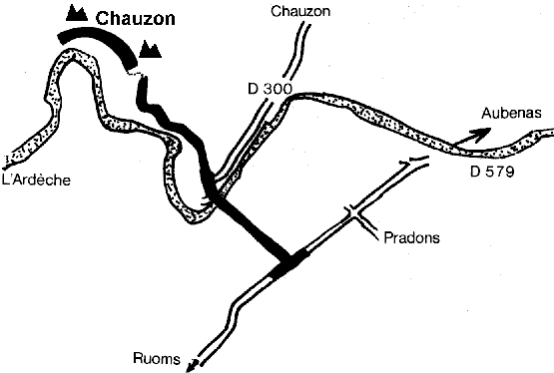

Cartes / Maps
- Michelin : No. 80, pli/folder 9
- IGN 1:25000 : 2938-O

Topos-guides
- Guide des sites d'escalade de l'Ardèche, Comité Départemental FFME Ardèche, 1999.

Accès / Access
Leave D579 (Ruoms-Vogüé) at southern entrance of Pradons; take D308 direction Chauzon, cross Ardèche river; do not turn right to Chauzon village, but continue in front until a parking. Take a ffot path on the left (S) leading to the roght bank of Ardèche river, follow it downstream until the crags. Caution: access to the river forbidden to vehicles.

*** Chaulet
Located in the lower Chassezac gorges, 1.3 km NE of Mazet-Plage and of Casteljau vacation village, Chaulet is an upper jurassic limestone crag facing plain south just above the Chassezac river. In mid-summer, at sunbathing hours you have better leave the sunbathers occupy the bottom of the routes; anyway it is so hot that one is so much better inside the water... 123 routes, 30-45 m, from 3c to 8a, but most interesting routes are between 6a and 8a, sttep and athletic. Easier routes are either short or polished, or both.

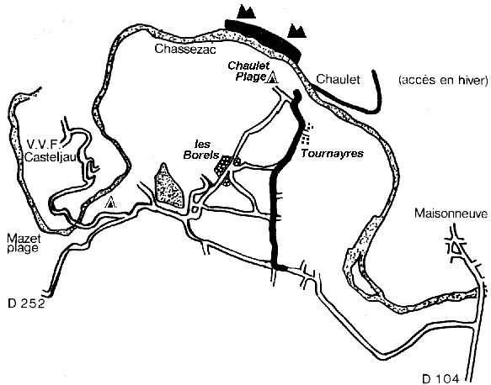

Cartes / Maps
- Michelin : No. 80, pli/folder 8
- IGN 1:25000 : 2939-E

Topos-guides
- Guide des sites d'escalade de l'Ardèche, Comité Départemental FFME Ardèche, 1999.

Gîtes/Lodge, Camping
- Campings à Chaulet-Plage
- Gîte/lodge à Chaulet-Plage, +33-4.75.30.30.27

Accès / Access
Leave road D104 (Aubenas-Alès via Joyeuse) 700 m north of the crossroads with D111 (Ruoms-St-Paul-le-Jeune) and take D252 westwards for 2 km; turn right (N) direction Chaulet-Plage through Tournayres or Les Borels; in Chaulet-Plage turn right (N) to reach a café avoiding entering the campsites and park. Ford the Chassezac river upstream of the pebble beach of Chaulet-Plage.

*** Mazet-Plage
Located 5 km east of Les Vans, 15 km west of Vallon-Pont-d'Arc, Mazet-Plage is the oldest climbing crag of the Ardèche departement. Facing west in a meander of Chassezac river, rock is an upper jurassic stratified limestone. In summer, bathing in the river is required stating from 2 pm.
90 routes, 20-50 m, 3b-7c. Equipment is excellent but the 15 lower meters of the classics are terribly polished. This place is especially pleasant in all seasons, rather protected from Mistral wind.

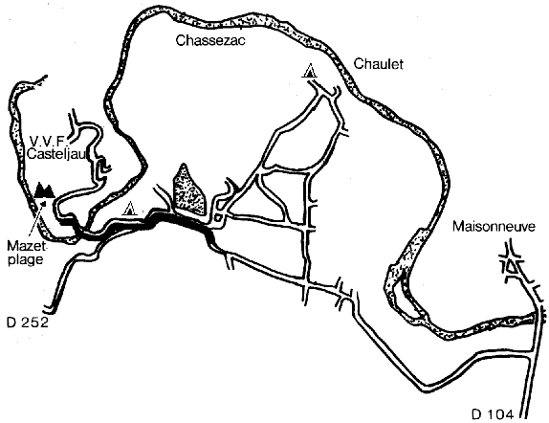

Cartes / Maps
- Michelin : No. 80, pli/folder 8
- IGN 1:25000 : 2939-E

Topos-guides
- Guide des sites d'escalade de l'Ardèche, Comité Départemental FFME Ardèche, 1999.

Gîtes/Lodge, Camping
- Camping (avril-septembre) au VVF de Casteljau et à Mazet-Plage. Campins ouverts en permanence : year round à Vallon-Pont-d'Arc.
- Gîte/lodge à Chaulet-Plage, +33-4.75.30.30.27

Accès / Access
Leave road D104 (Aubenas-Alès via Joyeuse) 700 m north of the crossroads with D111 (Ruoms-St-Paul-le-Jeune) and take D252 westwards for 3 km until Mazet-Plage; cross the Chassezac on a big bridge and park. Walk douwn westwards and discover the crag saing west above a pebble beach.

*** Salavas, Font-Garnide
Located 1.8 km WNW of Vallon-Pont-d'Arc, 0.8 km WNW of Salavas village, this is NW facing crfag, pleasant in summer mornings and afternoon in chilly seasons. 103 routes, 25-35 m, 4c-8b. Rock is a lower cretaceous limestone (urgonian) with many hadly visible pocket and holes. In case of difficulty in a move, specialists will advise you to bet there is a good gripping hand hold in some dubious hollow; works in 90 % of cases!
A crowded site where medium routes (4c-6a) are often polished, therefore athletic. Equipment is nearly perfect.

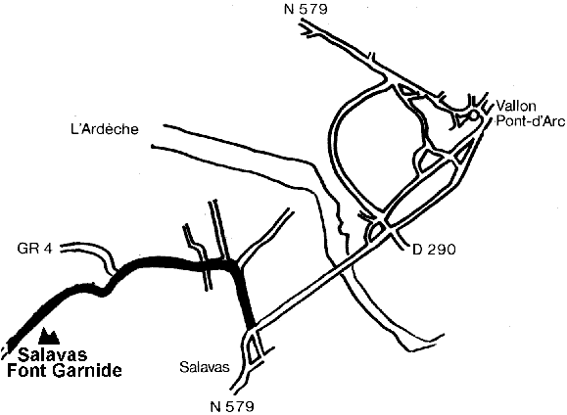

Cartes / Maps
- Michelin : No. 80, pli/folder 9
- IGN 1:25000 : 2939-O

Topos-guides
- Guide des sites d'escalade de l'Ardèche, Comité Départemental FFME Ardèche, 1999.

Accès / Access
From Vallon-Pont-d'Arc take road D579 until Salavas, then first road right (NW) for 300 m, then left (SW) for 500 m. before a right bend (small bridge) take the good dirt road ascending on left, follow it 700 m and park. A good cairned foot path lead to the crag.
Chauzon
- Lage:  Frankreich, Rhône, Aubenas  Wände im Ardeche-Tales  - Anfahrt:  - Von Aubenas aus auf der N 104 und dann auf die D 579 Richtung Vallon-Pont-d'Arc.  - Nach Pradons rechts auf die D 308 Richtung Chauzon abbiegen.  - In Chauzon über die Brücke und weiter geradeaus bergauf fahren, bis die Schotterstraße endet.  - Dort parken und zu den Wänden in die Schlucht absteigen.  - Bewertungssystem / Schwierigkeit:  französische Skala  4+ bis 8a  - Gebietsumfang:  unter 300 Routen | - Gestein / Routen:  Kalk  typische Kalkkletterei  - Kletterführer:  Marschner, Timo. Schorer, Gerd. (1996).  Mistral - Sportkletterführer Südfrankreich I.  Weinstadt: Rotpunkt Verlag.  - Bemerkung:  - Gleich neben dem Klettergebiet befindet sich ein Zeltplatz.  - Falls es zum Klettern etwas zu heiß ist, kann man in der Ardeche baden gehen.  - Die Schwierigkeitsbewertung mancher Routen erschien mir "etwas über den Daumen gepeilt".

